Set 21: Energy Consumption Data Analysis
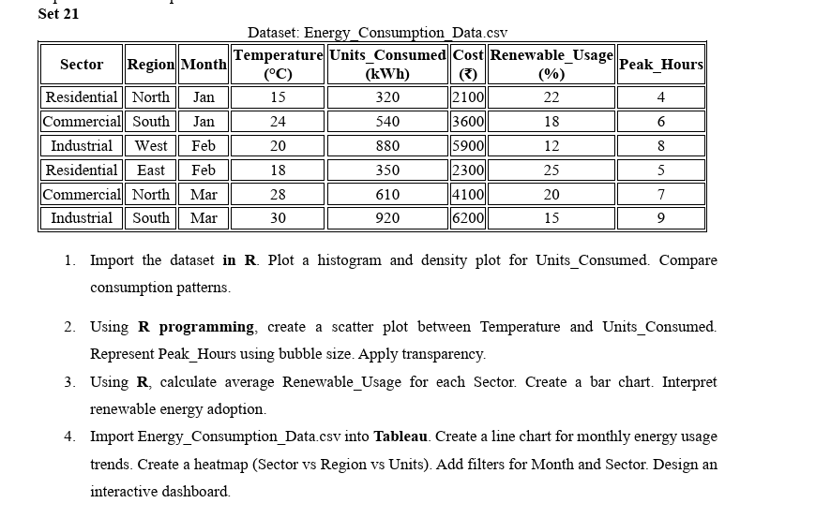

Question 1: Import the dataset in R. Plot a histogram and density plot for Units_Consumed. Compare consumption patterns.
Aim:
To import the dataset into R and visualize the distribution of Units_Consumed using a histogram and density plot.
Code:
data <- read.csv("Energy_Consumption_Data.csv")

hist(data$Units_Consumed,
main = "Histogram of Units Consumed",
xlab = "Units Consumed (kWh)",
ylab = "Frequency",
col = "skyblue",
border = "black")

plot(density(data$Units_Consumed),
main = "Density Plot of Units Consumed",
xlab = "Units Consumed (kWh)",
ylab = "Density",
col = "blue",
lwd = 2)
Output:
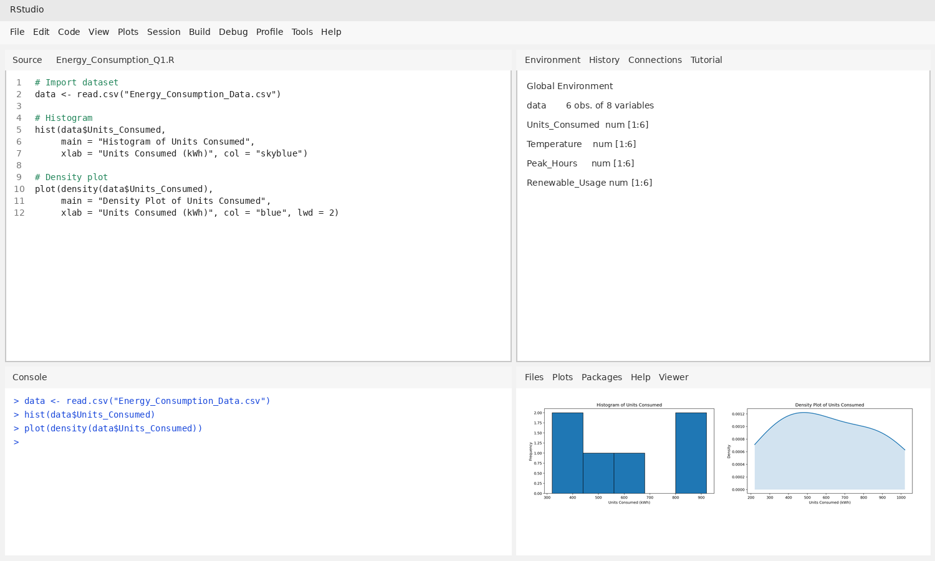
RESULT:
Thus, the histogram and density plot were created successfully. The units consumed range from 320 to 920 kWh, showing low, medium, and high consumption values.

Question 2: Using R programming, create a scatter plot between Temperature and Units_Consumed. Represent Peak_Hours using bubble size. Apply transparency.
Aim:
To examine the relationship between temperature and units consumed, with bubble size representing peak hours and transparency reducing overlap.
Code:
data <- read.csv("Energy_Consumption_Data.csv")

plot(data$Temperature, data$Units_Consumed,
cex = data$Peak_Hours / 3,
pch = 21,
bg = rgb(0.2, 0.6, 0.9, 0.45),
xlab = "Temperature (°C)",
ylab = "Units Consumed (kWh)",
main = "Temperature vs Units Consumed")
Output:
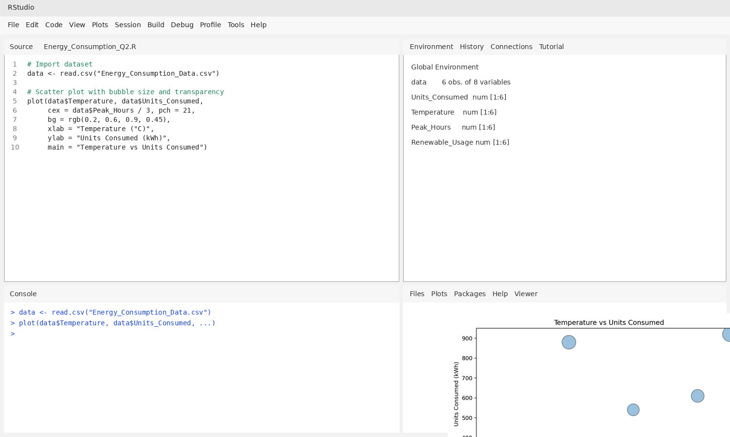
RESULT:
Thus, the scatter plot was created successfully. In the given sample, higher temperatures generally correspond to higher energy consumption. Larger bubbles represent more peak hours.

Question 3: Using R, calculate average Renewable_Usage for each Sector. Create a bar chart. Interpret renewable energy adoption.
Aim:
To calculate the average renewable energy usage for each sector and compare the values using a bar chart.
Code:
data <- read.csv("Energy_Consumption_Data.csv")

avg <- aggregate(Renewable_Usage ~ Sector,
data = data, mean)
print(avg)

barplot(avg$Renewable_Usage,
names.arg = avg$Sector,
col = c("skyblue", "orange", "lightgreen"),
main = "Average Renewable Usage by Sector",
xlab = "Sector",
ylab = "Average Renewable Usage (%)")
Output:
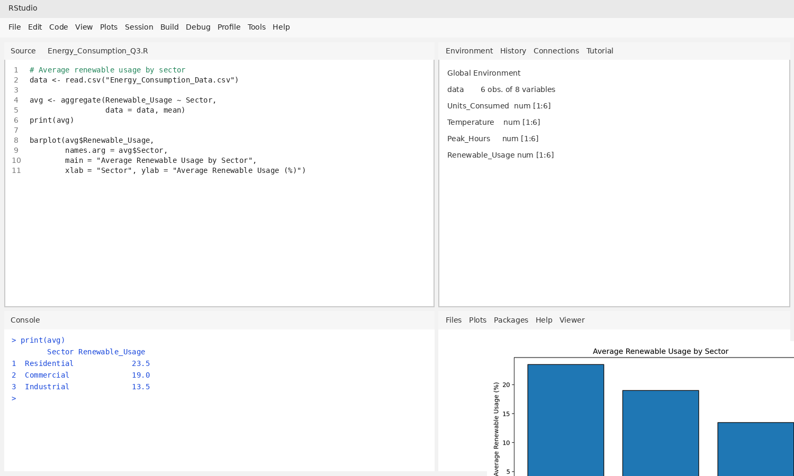
RESULT:
Thus, the bar chart was created successfully. Average renewable usage is Residential = 23.5%, Commercial = 19.0%, and Industrial = 13.5%. Residential has the highest average in this dataset.

Question 4: Import Energy_Consumption_Data.csv into Tableau. Create a line chart for monthly energy usage trends. Create a heatmap (Sector vs Region vs Units). Add filters for Month and Sector. Design an interactive dashboard.
Aim:
To create a Tableau dashboard displaying monthly energy usage and a Sector-versus-Region heatmap with Month and Sector filters.
Procedure:
- Connect Tableau to Energy_Consumption_Data.csv using the Text File connector.
- For the line chart, place Month on Columns and SUM(Units_Consumed) on Rows; choose Line in the Marks card.
- For the heatmap, place Sector on Rows, Region on Columns, and Units_Consumed on Color and Label.
- Add Month and Sector to Filters and select Show Filter for both.
- Create a dashboard and add both charts. Keep the filters visible for interactive exploration.
Output:
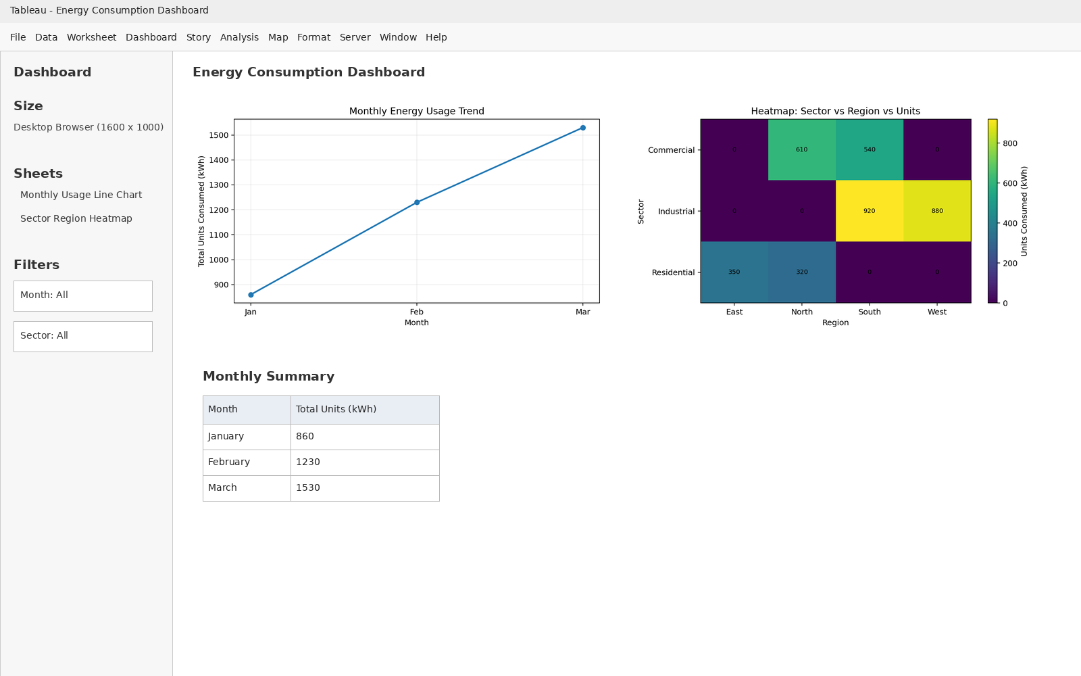
RESULT:
Thus, the dashboard-style output was prepared with a monthly usage chart, a sector-region heatmap, and Month and Sector filter controls. The monthly totals are January = 860 kWh, February = 1,230 kWh, and March = 1,530 kWh. The screenshot is a designed example of the Tableau layout; the interactive dashboard must be built in Tableau.

